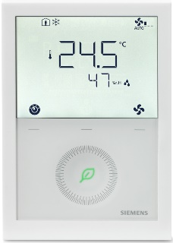   | - Devices: RDG260KN (white), RDG260KN/BK (black)  RDG264KN (CO₂), RDG260T (standalone, white), RDG260T/BK (standalone, black)  - Powered with AC 24V or DC 24V  - Temperature and humidity measurement  - Temperature or temperature and humidity control  - Air cooling  - Heating or cooling  - On/Off or DC 0…10 V control of heating / cooling actuators  - On/Off or DC 0…10 V control electric heaters  - Automatic or manual fan speed control: 1-speed, 3-speed or DC Fan  - Automatic or manual heating / cooling changeover  - Multifunctional inputs for keycard contact, external sensor, etc.  - Adjustable commissioning and control parameters  - Backlit LCD  - KNX bus communications

Plant diagram | 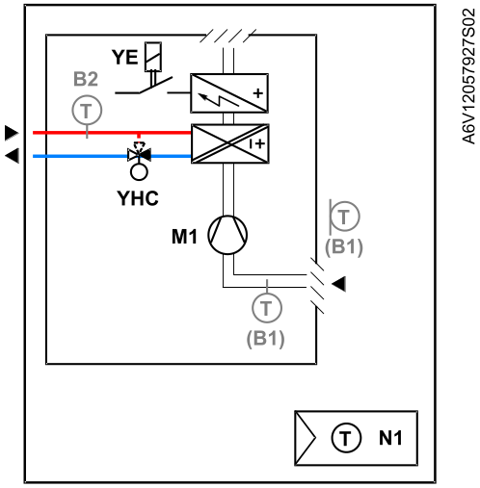

Description  of functions | When"2-pipe fan coil with electric heater" is selected (via DIP switches or tool), the following functions are available.  For details see basic documentation (A6V11545892 for RDG260KN)

 | Control sequence
 | - Control of thermal or motorized valve actuators (On/Off or DC 0…10 V)
 | - Heating only or Cooling only
 | - Control of electric heaters (On/Off or DC 0…10 V)
 | - Manual or automatic heating / cooling changeover |  | Other functions
 |  |  | - Button lock
 | Fan control |  | - 2nd line display setting
 | - 1-speed, 3-speed or DC Fan, automatic |  | - Setting access with password protection
 | - Manual speed control on room thermostat |  | - Valve exercising to prevent from gripping
 | - Fan control in dead zone
 | - Fan start related to the coil temperature |  | Humidity control
 |  |  | - By shifting temperature setpoint
 |  |  | - By controlling an external equipment
 | Room and humidity temperature measurement
 | - Internal sensor
 | - External room temperature sensor |  | Indoor Air Quality monitoring and control
 | - External return air sensor |  | - RDG264KN only
 |  |  | - IAQ monitor with indication of the CO₂ value or IAQ status in text (GOOD FAIR BAD) on the display
 | 3 multifunctional inputs |  | - For IAQ control, selectable CO₂ setpoint and differential (0% to 100%) via parameters,
 | - Temperature (Room, return air, changeover …)  - Digital (changeover, presence, window contact …) |  | - IAQ control by driving fresh air damper and running the fan built into fan coil
 |  |  | - IAQ control by driving external fresh air damper and running the fan
 |  |  | - IAQ control by driving external fresh air damper in universal heating / cooling applications
Device list | <START StandardDeviceList>  <END StandardDeviceList>
  Legend | Type of unit | Data sheet | Product No. | Qty.
  N1 | Room thermostat with KNX communications, AC 24V or DC 24 V, for fan coil units and universal applications | A6V11545853 | RDG260KN | 1
  YHC | 2- or 3-port valve |  | V..P4.. | 1
   | Actuator for small valves, 2-position, PWM or 3-position, AC 24 V or AC 230 V |  | SS..6.. / ST..2.. | 1
 | + For selection of actuators and valves please refer to the product catalog

Optional | <START OptionalDeviceList>  <END OptionalDeviceList>
  Legend | Type of unit | Data sheet | Product No. | Qty.
  B1 | Cable temperature sensor PVC 2.5 m, NTC 3 kOhm, with connectors 2.8 x 0.8 mm | N1840 | QAH11 | 1
  B2 | Cable temperature sensor PVC 2.5 m, NTC 3 kOhm, with connectors 2.8 x 0.8 mm | N1840 | QAH11 | 1

Variants | <START VariantsDeviceList>  <END VariantsDeviceList>
  Legend | Type of unit | Data sheet | Product No. | Qty.
  N1a | Room thermostat with KNX communications, AC 24 V or DC 24 V, for fan coil units and universal applications  Black version with product index D or higher | A6V11545853 | RDG260KN/BK | 1
  N1b | Room thermostat with KNX communications and CO₂ sensor, AC 24 V or DC 24 V, for fan coil units and universal applications with product index D or higher | A6V11545853 | RDG264KN | 1
  N1c | Room thermostat, AC 24 V or DC 24 V, for fan coil units and universal applications | A6V13375643 | RDG260T | 1
  B1a | Room temperature sensor NTC 3 kOhm | N1747 | QAA32 | 1

Connection diagram
  DC 0…10 V fan | 1-speed/3-speed fan
  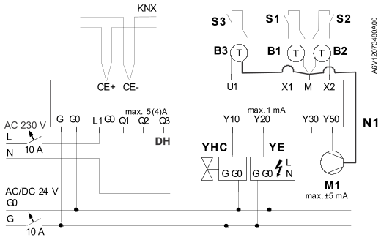 | 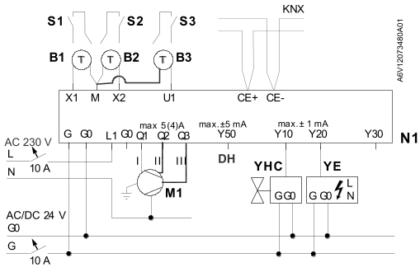

 | N1 | Room thermostat RDG260KN |  | B1, B2, B3 | Optional external sensors
 | M1 | 1-speed; 3-speed or DC 0…10V fan |  | S1, S2, S3 | Optional switches
 | YHC | Heating / cooling valve actuator  (On/Off, DC 0…10 V) |  | CE+, CE- | KNX bus
 | YE | Electric heater (On/Off or DC 0…10 V) |  | DH | Dehumidifier: Q3=On/Off, Y50=0…10 V
Notes
- Type of control output selectable via DIP switches and parameters P201 and P203 (On/Off, DC 0…10 V).
- Multifunctional input function selectable via parameters P150 to P156 (Room temp. / return air temp, H/C changeover, window contact, dewpoint sensor, fault input)
- 3-speed, 1-speed or DC fan selectable via parameter P351
- For RDG264KN, fresh air damper can be connected to U1 output.

Setting option | Device can be set via
 | - DIP switches and parameters  - Smartphone APP PCT Go for Android™ and iOS  - Remotely via KNX tools such as Siemens ACS, ETS5 or higher versions |  |  | 
DIP switch settings | Application | DIP switches |  |  | Remark
 | Remote configuration (factory setting) | 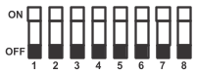 |  |  | Application, outputs and parameters will be downloaded via commissioning tool
 | Remote configuration (factory setting) | ON = | OFF =
 | Remote configuration (factory setting) | DIP No.: 1…8 | DIP No.: 1…8
Application | 2-pipe fan coil with electric heater | 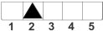 |  |  | Set DIP switch 2
Control outputs | - Heating / cooling actuator DC 0…10 V  - Electric heater DC 0…10 V | 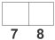 |  |  | Set DIP switches 7 and 8
 | - Heating / cooling actuator On/Off  - Electric heater On/Off | 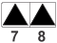 |  |  | Set DIP switches 7 and 8
 | - Heating / cooling actuator DC 0…10 V  - Electric heater On/Off | 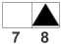 |  |  | Set DIP switches 7 and 8
 | - Heating / cooling actuator On/Off  - Electric heater DC 0…10 V | 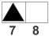 |  |  | Set DIP switches 7 and 8
Fan | - DC fan | 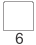 |  |  | Set DIP switch 6  If DIP = "3-speed fan":  Select 1-speed fan, 3-speed fan via P351  - 1-speed fan = 1  - 3-speed fan = 2
Fan | - 1-speed fan, 3-speed fan | 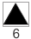

Main settings | Function |  | Parameters | Remarks
Control sequence | Select the control sequence(s) of the controller |  | P001= 0…3 | 0 = Heating only
 |  |  |  | 1 = Cooling only (Factory setting)
 |  |  |  | 2 = H/C changeover auto
 |  |  |  | 3 = H/C changeover manual
General parameters | User operating mode profile |  | P002 = 1…3 | 1 = Auto – Protection (Factory setting)  2 = Auto – Comfort – Economy – Protection  3 = Auto – Protection Hospitality
 | User fan mode selection |  | P003 = 0...3 | 0 = Auto – Manual (Factory setting)  1 = Manual  2 = Auto – Manual – Protection  3 = Auto – Protection
 | Standard temperature display |  | P008 = 0, 1 | 0 = Room temperature (Factory setting)  1 = Setpoint
 | Additional display information |  | P009 = 0…5 | 0 = --- (No display) (Factory setting)
 |  |  |  | 1 = °C and °F
 |  |  |  | 2 = Outside temperature (via bus)
 |  |  |  | 3 = Time of day (12 h) (via bus)
 |  |  |  | 4 = Time of day (24 h) (via bus)
 |  |  |  | 5 = Humidity
 | Comfort setpoint |  | P011 = 5...40 °C | Factory setting 21 °C
 | Economy heating setpoint |  | P019 = OFF, 5 °C…P020 | Factory setting 15 °C
 | Economy cooling setpoint |  | P020 =OFF,  P019…40 °C | Factory setting 30 °C  .
Electric heater | Allow electric heater in cooling mode | P027 = ON, OFF |  | ON = Enabled (Factory setting)
 |  |  |  | OFF = Disabled
 | Power of electric heater on  Q2 [kW] | P217 = 0…1.2 kW |  | Factory setting: 0 kW
 | Fan overrun | P352 = 0…600 s |  | Factory setting: 60 s

Multifunctional inputs, digital input | External / return air temperature | P150 = 1 | Factory set on X1
Multifunctional inputs, digital input | No function | P153 = 0 | Factory set on X2,
 | Window contact | P155 = 3 | Factory set on U1
Inputs selection | 0 = --- (no function) |  | 8 = Monitor input (Temp) (AI)
 | 1 = Room temp ext. sensor / return (AI) |  | 9 = Supply air sensor (AI)
 | 2 = H/C changeover (AI/DI) |  | 10 = Presence detector / card reader (DI)
 | 3 = Window contact [PROT] (DI) |  | 11 = External temperature limit (AI)
 | 4 = Dewpoint sensor (DI) |  | 12 = Coil temperature (AI)
 | 5 = Enable electric heater (DI) |  | 13 = Hotel presence detector / card reader (DI)
 | 6 = Fault input (DI) |  | 14 = Coil return temperature (AI)
 | 7 = Monitor input (Digital)(DI)
Fan setting | Fan type 1-speed | P351 = 1
Fan setting | Fan type 3-speed | P351 = 2
Fan setting | DC fan | P351 = 3
Humidity control | Control strategy | P450 = 0 | Only temperature control (default)
Humidity control |  | P450 = 1 | Temperature and humidity control
Humidity control | Setpoint humidity high | P024 = OFF, P026 or 20…90 % | Factory setting: 50
Humidity control | Humidity setpoint high ECO | P025 = --- (0), P026…90 %, or 20…90 % | Factory setting: OFF
Humidity control | Setpoint humidity low | P026 = OFF, 20…90 % or P024 | Factory setting: OFF
Humidity control | Max shift temp setpoint (Dehumid.) | P461 = -3...3 K | Temperature setpoint deviation due to the humidity in the room
Air cooling | Temperature + Air damper + Air cooling | P450 = 5 | Temperature and air cooling control
Air cooling | Temperature + Air damper + 2nd air cooling | P450 = 6 | Temperature and air cooling control
Air cooling | Minimum damper position | P455 = 0 %…P457 | Factory setting: 0%
Air cooling | Maximum damper position | P457 = P455…100 % | Factory setting: 100%
Air cooling | Fan during damper control | P458 = ON
Air cooling | Outside damper frost protection | P109 = ---; 2...14 °C (36...50 °F) | Factory setting: ---
Engineering | For a complete list of parameters and detailed description of functions see basic documentation:  A6V11545892 for RDG260KN;  For engineering of RDG in conjunction with  - Synco see CE1P3127 (Communication via the KNX bus for Synco 700, Basic documentation)  - Desigo PXC, see A6V11980394 (Desigo PXC – Technical presentation – Ready to control) on Highspot

Energy efficiency
Heating control |  | Evaluation |  | Definition of classes |  |  |  |  |  |  |  | Remarks
 |  | RDG26..KN.. | RDG260T.. | Residential |  |  |  | Non residential |  |  |  | Remarks
 |  | RDG26..KN.. | RDG260T.. | D | C | B | A | D | C | B | A | Remarks
1.1 Emission control
The control function is applied to the heat emitter (radiators, underfloor heating, fan-coil unit, indoor unit) at room level; for type 1 one function can control several rooms
0 | No automatic control
1 | Central automatic control
2 | Individual room control |  | X
3 | Individual modulating room control with communication | X
4 | Individual modulating room control with communication and occupancy detection (not applied to slow reacting heating emission systems, e.g. floor heating) | X |  |  |  |  |  |  |  |  |  | 29
1.2 Emission control for TABS (heating mode)
0 | No automatic control
1 | Central automatic control
2 | Advanced central automatic control
3 | Advanced central automatic control with intermittent operation and/or room temperature feedback control
1.3 Control of distribution network hot water temperature (supply or return)
Similar function can be applied to the control of direct electric heating networks
0 | No automatic control
1 | Outside temperature compensated control
2 | Demand based control
1.4 Control of distribution pumps in networks
The controlled pumps can be installed at different levels in the network
0 | No automatic control
1 | On off control
2 | Multi-stage control
3 | Variable speed pump control (pump unit (internal) estimations)
4 | Variable speed pump control (external demand signal)
1.4.a Hydronic balancing heating distribution (including contribution to the balancing to the emission side)
Hydronic balancing is applied to an emitter or a group of heat emitters greater than 10
0 | No balancing
1 | Balanced statically per emitter, without group balance
2 | Balanced statically per emitter and a static group balance
3 | Balanced statically per emitter and dynamic group balance
4 | Balanced dynamically per emitter
1.5 Intermittent control of emission and/or distribution
One controller can control different rooms/zones having same occupancy patterns
0 | No automatic control
1 | Automatic control with fixed time program
2 | Automatic control with optimum start/stop
3 | Automatic control with demand evaluation
1.6 Heat generator control (combustion and district heating)
0 | Constant temperature control
1 | Variable temperature control depending on outside temperature
2 | Variable temperature control depending on the load
1.7 Heat generator control (heat pump)
0 | Constant temperature control
1 | Variable temperature control depending on outside temperature
2 | Variable temperature control depending on the load
1.8 Heat generator control (outdoor unit)
0 | On/off-control of heat generator
1 | Multi-stage control of heat generator
2 | Variable control of heat generator
1.9 Sequencing of different heat generators
0 | Priorities only based on running time
1 | Control according to fixed priority list
2 | Control according to dynamic priority list
3 | Control according to prediction based dynamic priority list
1.10 Control of thermal energy storage (TES) operation
0 | Continuous storage operation
1 | 2-sensor charging of storage
2 | Load prediction-based storage operation

Energy efficiency
Cooling control |  | Evaluation |  | Definition of classes |  |  |  |  |  |  |  | Remarks
 |  | RDG26..KN.. | RDG260T.. | Residential |  |  |  | Non residential |  |  |  | Remarks
 |  | RDG26..KN.. | RDG260T.. | D | C | B | A | D | C | B | A | Remarks
3.1 Emission control
The control function is applied to the emitter (cooling panel, fan-coil unit or indoor unit) at room level; for type 1, one function can control several rooms
0 | No automatic control
1 | Central automatic control
2 | Individual room control |  | X
3 | Individual modulating room control with communication | X
4 | Individual modulating room control with communication and occupancy detection (not applied to slow reacting cooling emission systems, e.g. floor cooling) | X |  |  |  |  |  |  |  |  |  | 29
3.2 Emission control for TABS (cooling mode)
0 | No automatic control
1 | Central automatic control
2 | Advanced central automatic control
3 | Advanced central automatic control with intermittent operation and/or room temperature feedback control
3.3 Control of distribution network chilled water temperature (supply or return)
Similar function can be applied to the control of direct electric cooling (e.g. compact cooling units, split units) for individual rooms
0 | Constant temperature control
1 | Outside temperature compensated control
2 | Demand based control
3.4 Control of distribution pumps in networks
The controlled pumps can be installed at different levels in the network
0 | No automatic control
1 | On off control
2 | Multi-stage control
3 | Variable speed pump control (pump unit (internal) estimations)
4 | Variable speed pump control (external demand signal)
3.4.a Hydronic balancing cooling distribution (including contribution to the balancing to the emission side)
Hydronic balancing is applied to a group of cooling emitters (cooling panel, fan-coil unit or indoor unit) greater than 10, in addition to static balancing at individual cooling emitters
0 | No balancing
1 | Balanced statically per emitter, without group balance
2 | Balanced statically per emitter, and a static group balance (e.g. with balancing valve)
3 | Balanced statically per emitter and dynamic group balance
4 | Balanced dynamically per emitter
3.5 Intermittent control of emission and/or distribution
One controller can control different rooms/zones having same occupancy patterns
0 | No automatic control
1 | Automatic control with fixed time program
2 | Automatic control with optimum start/stop
3 | Automatic control with demand evaluation
3.6 Interlock between heating and cooling control of emission and/or distribution
0 | No interlock
1 | Partial interlock (dependent on the HVAC system)
2 | Total interlock
3.7 Generator control for cooling
The goal consists generally in maximizing the chilled water supply temperature
0 | Constant temperature control
1 | Variable temperature control depending on outside temperature
2 | Variable temperature control depending on the load
3.8 Sequencing of generators for chilled water
0 | Priorities only based on running time
1 | Fixed sequencing based on loads only
2 | Priorities based on generator efficiency and characteristics
3 | Load prediction-based sequencing
3.9 Control of thermal energy storage (TES) operation
0 | Continuous storage operation
1 | Time-scheduled storage operation
2 | Load prediction-based storage operation

Summary | Energy efficiency class: RDG26..KN.. A  RDG260T.. C
 | Only together with Efficiency Class A application

Remarks | No. | Remark
 | 29 | Occupancy detector required
 | Home automation / building automation and control system and technical home/building management required satisfying Efficiency Class A
 | Efficiency Class rating based on EN ISO 52120-1: 2022

Issued by  Siemens Switzerland Ltd  Smart Infrastructure  Global Headquarters  Theilerstrasse 1a  CH-6300 Zug  Tel. +41 58 724 2424  www.siemens.com/buildingtechnologies | © Siemens Switzerland Ltd, 2020  Technical specifications and availability subject to change without notice.

