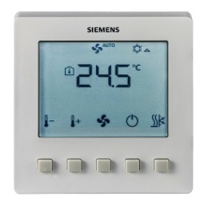 | - Heating or/and cooling  - LCD backlit display  - ON/OFF control of heating and cooling actuators  - Automatic or manual 3-speed fan control  - Time with delay Off function  - Adjustable commissioning and control parameters  - Fit into 86x86 conduit boxes

Variants for room thermostats | Backlit for LCD | Universal Inputs X1 & X2 | 86x86 conduit boxes  e.g. ARG71 | Round CEE conduit box  e.g. VDE/DIN
RDF300.02
RDF600
RDF600T

Plant diagram | 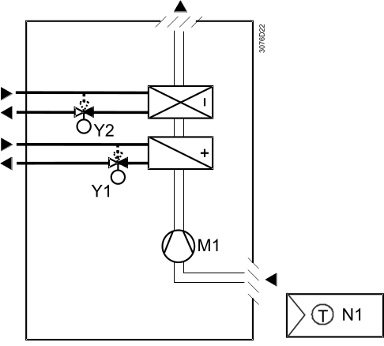

Function diagram  (valve actuators ON/OFF) | Example: heating and cooling mode (P01 = 04)
Function diagram  (valve actuators ON/OFF) | 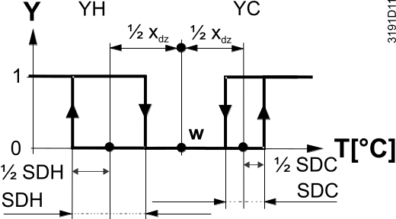
  T | Room temperature
  w | Room temperature setpoint
  Y | Output signal
  YH | Control command “Valve” (heating)
  SDH | Switching differential “Heating” (P30)
  SDC | Switching differential “Cooling” (P31)
  Xdz | Dead zone (P33)
  YC | Control command “Valve” (cooling)

Function diagram  (fan) | Fan control in case of 2-position valve control (ON/OFF)
Function diagram  (fan) | 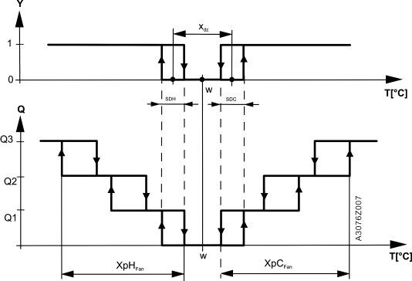

 | T[°C] | Room temperature | SDH | Switching differential “Heating” (P30)
 | w | Room temperature setpoint | SDC | Switching differential “Cooling” (P31)
 | Q1 | Fan speed 1 | Xdz | Dead zone (P33)
 | Q2 | Fan speed 2 | XpHFan | Switching range for fan “Heating”
 | Q3 | Fan speed 3 | XpCFan | Switching range for fan “Cooling”
 | Y | Control command “Valve”
SDH/SDC [K] | 0.5 | 1.0 | 1.5 | 2.0 | 2.5 | 3.0 | 3.5 | 4.0 | >4.5
XpH_{Fan}/XpC_{Fan} [K] | 2 | 3 | 4 | 5 | 6 | 7 | 8 | 9 | 10

Description  of functions | For details, please refer to individual data sheet. e.g. A6V10889950.
 | Sequence |  | Room operating modes
 | - Control of thermal or motorized valve actuators  (ON/OFF) |  | - Comfort and Protection (Off) mode
 | - Heating and cooling (P01 = 4, factory setting)
 | - Manual heating / cooling changeover (P01 = 2) |  | Room temperature measurement
 |  |  | - Internal sensor
 | Fan control
 | - Automatic |  | Setpoint adjustment
 | - 1...3-speed manual speed control on room thermostat |  | - Locally on room thermostat (via HMI of thermostat)
 | - Fan control in dead zone for Comfort mode (P15)
 | Note: More details about advanced fan settings are available in data sheet.

Device list | <START StandardDeviceList>  <END StandardDeviceList>
  Legend | Type of unit | Data sheet | Product No. | Qty.
  N1 | Semi flush-mount room thermostat, 4-pipe fan coils | A6V10889950 | RDF530 | 1
  Y1 | 2- or 3-port valve | N4842 | V...I46 | 1
   | Actuator for small valves, 2-position or 3-position, AC 230 V | A6V10446174 | SUA21/3 | 1
  Y2 | 2- or 3-port valve | N4842 | V...I46 | 1
   | Actuator for small valves, 2-position or 3-position, AC 230 V | A6V10446174 | SUA21/3 | 1
 | For selection of actuators and valves, please refer to the product catalog.
Connection diagram | 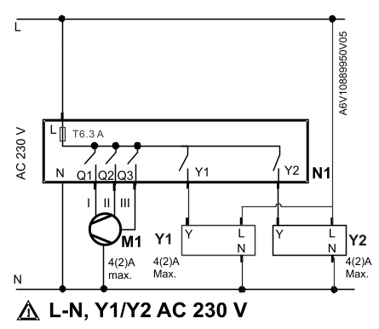
  N1 | RDF room thermostat
  M1 | 3-speed fan
  Y1, Y2 | On/Off valves: Siemens SUA21/3
  T6.3 A | Internal fuse (6.3 A), replaceable
  Notes：
  - Connect only one fan at a time to output Q on the thermostat.
  - The fuse supports a total maximum loading (fan and valve) of 5 A.

Variants | <START VariantsDeviceList>  <END VariantsDeviceList>
  Legend | Type of unit | Data sheet | Product No. | Qty.
  Y1a | Electrometric ON/OFF valve and actuator | N4867 | M..I421.. | 1
  Y1b | Small valve (externally threaded) | N4847 | V..P47.. | 1
   | ON/OFF actuator, 2P | N4884  N4865 | STP..  SFP.. | 1
  Y1c | 2- or 3-port valve | N4842 | V...I46 | 1
   | Actuator for small valves, 2-position or 3-position, AC 230 V | N4863  N4884 | SFA21...  STA23 | 1
  Y2a | Electrometric ON/OFF valve and actuator | N4867 | M..I421.. | 1
  Y2b | Small valve (externally threaded) | N4847 | V..P47.. | 1
   | ON/OFF actuator, 2P | N4884  N4865 | STP..  SFP.. | 1
  Y2c | 2- or 3-port valve | N4842 | V...I46 | 1
   | Actuator for small valves, 2-position or 3-position, AC 230 V | N4863  N4884 | SFA21...  STA23 | 1

Parameter settings  (fan) | Parameters | Description | Setting range | Factory setting
Parameter settings  (fan) | P15 | Fan control in dead zone for Comfort mode | 0 = Fan off  1 = Fan speed 1 in heating or cooling mode | 1
Parameter settings  (fan) | P59 | Fan minimum on-time | 1…6 minutes | 2 minutes

Miscellaneous parameters | Parameters | Description | Setting range | Factory setting
 | P01 | Control sequence | 2 = H/C manual changeover  4 = Heating and cooling | 4
 | P05 | Sensor calibration | -5…+5 K | 0 K
 | P06 | Standard temperature display | 0 = Room temperature  1 = Setpoint | 0
 | P09 | Minimum setpoint in Comfort mode | 5 °C | 5 …40 °C
 | P10 | Maximum setpoint in Comfort mode | 35 °C | 5 …40 °C
 | P14 | Keylock function | 0 | 0 = No lock  1 = Full lock
 | P27 | Operating mode settings upon power down | 0 | 0 = Return to previous operating mode or user settings  1 = Protection mode
 | P28 | Timer with delay Off | 0 | 0 = Users to set on-time duration  1 to 23 = Preset with a fixed on-time in hours
 | P30 | Switching differential in heating mode | 1 K | 0.5…6 K
 | P31 | Switching differential in cooling mode | 1 K | 0.5...6 K
 | P33 | Deadzone in Comfort mode | 2 K | 0.5...5 K
 | P65 | Protection heating setpoint | 8 °C | OFF, 5 °C…Wcool_{pro}; Wcool_{pro}=40 °C max.
 | P66 | Protection cooling setpoint | OFF | OFF, Wheat_{pro}…40 °C; Wheat_{pro}=5 °C min.
 | P71 | Reload factory setting | OFF | OFF = Disable; ON = Reload start  ”---“ is displayed for 3 seconds during reload process.
Engineering | For a complete list of parameters and detailed description of functions see datasheet A6V10889950.
Subject to change. © 2017 Siemens Switzerland Ltd.

